A000-Am, S-Colombia-Tairona-Tumbaga-Woman kneeling with hands on her abdomen-1000-15000 CE

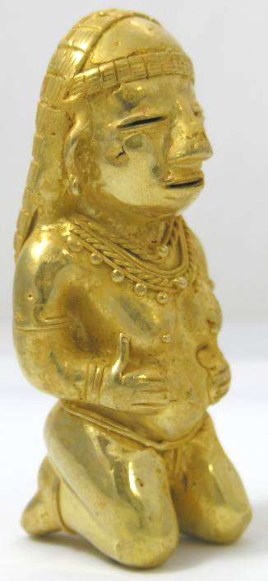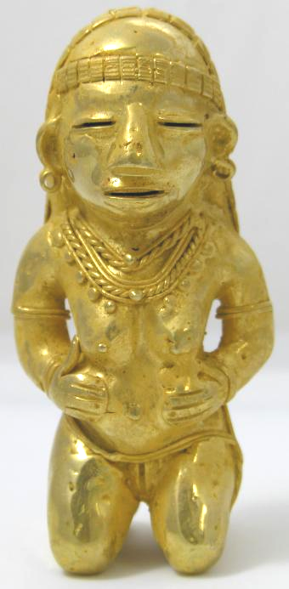

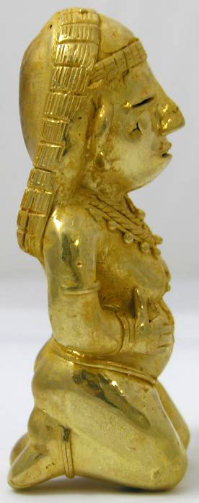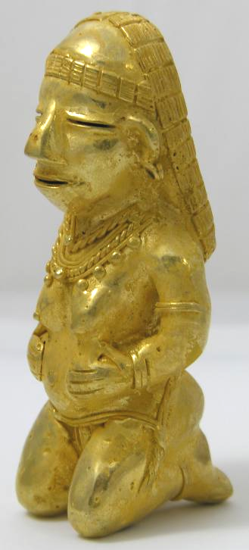

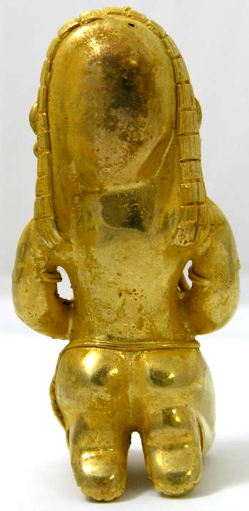 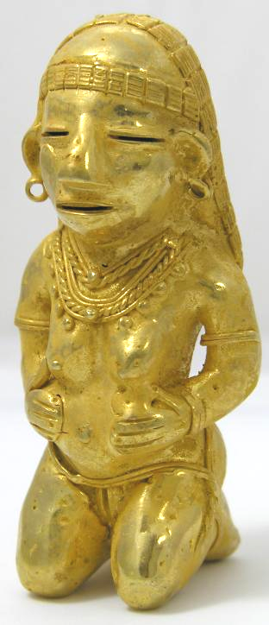

|  |
| --- |
| Payment details |
|  |
|  |
| Shipping details |
| **Ralph J Coffman Jr**  149 Atlantic Ave  Swampscott MA 01907-2427  United States |

## Order details

|  |  |  |  |
| --- | --- | --- | --- |
| **Item title** | **Available actions** | **Shipping & handling (estimated delivery*)** | **Price** |

[Printer version](http://payments.ebay.com/ws/eBayISAPI.dll?ViewPaymentStatus&transid=0&userloginid=802-867&orderid=123679848010&printerversion=true&itemid=110973759272)

|  |  |  |
| --- | --- | --- |
| Seller: | [**Member id** numismaqui13](http://myworld.ebay.com/numismaqui13) ( [**Feedback Score Of** 870](http://feedback.ebay.com/ws/eBayISAPI.dll?ViewFeedback&userid=numismaqui13)) | [Contact seller](http://contact.ebay.com/ws/eBayISAPI.dll?ShowCoreAskSellerQuestion&frm=3998&iid=0&redirect=0&requested=numismaqui13) |

|  |  |  |  |  |
| --- | --- | --- | --- | --- |
| **Order # 123679848010**  Paid on Nov-13-12 via PayPal | | | | |
|  |  | |  | | --- | |  | | |  |  | | --- | --- | | [Contact seller](http://contact.ebay.com/ws/eBayISAPI.dll?ShowCoreAskSellerQuestion&frm=3998&iid=110973759272&redirect=0&requested=numismaqui13) |  | | |  |  |

|  |  |  |  |  |  |  |  |
| --- | --- | --- | --- | --- | --- | --- | --- |
| [**Item Title:**COLOMBIA TUMBAGA TAIRONA GOLD ALLOY CARGADORA**- opens in a new window or tab**](http://cgi.ebay.com/ws/eBayISAPI.dll?ViewItem&item=110973759272)  **Item Id:**110973759272 - Price: US $100.00  Quantity:1  Having a problem with this purchase? [We can help](javascript:;) | |  | | --- | |  | | |  |  | | --- | --- | | [Leave feedback](http://feedback.ebay.com/ws/eBayISAPI.dll?LeaveFeedbackShow&useridfrom=802-867&useridto=numismaqui13&item=110973759272&transactid=0) |  | | | Standard Shipping: **US $60.00**  Estimated delivery: December 3 - December 19 | US $100.00 |
| [**Item Title:**COLOMBIA TUMBAGA TAIRONA FIGURE *** A STANDING WOMAN \*\*\***- opens in a new window or tab**](http://cgi.ebay.com/ws/eBayISAPI.dll?ViewItem&item=110973759501)  **Item Id:**110973759501 - Price: US $102.50  Quantity:1  Having a problem with this purchase? [We can help](javascript:;) | |  | | --- | |  | | |  |  | | --- | --- | | [Leave feedback](http://feedback.ebay.com/ws/eBayISAPI.dll?LeaveFeedbackShow&useridfrom=802-867&useridto=numismaqui13&item=110973759501&transactid=0) |  | | | Shipped with item above | US $102.50 |

|  |  |  |  |  |  |  |  |
| --- | --- | --- | --- | --- | --- | --- | --- |
| [**Item Title:**COLOMBIA TUMBAGA TAIRONA FIGURE *** PREGNANCY \*\*\***- opens in a new window or tab**](http://cgi.ebay.com/ws/eBayISAPI.dll?ViewItem&item=110973759722)  **Item Id:**110973759722 - Price: US $112.50  Quantity:1  Having a problem with this purchase? [We can help](javascript:;) | |  | | --- | |  | | |  |  | | --- | --- | | [Leave feedback](http://feedback.ebay.com/ws/eBayISAPI.dll?LeaveFeedbackShow&useridfrom=802-867&useridto=numismaqui13&item=110973759722&transactid=0) |  | | | Shipped with item above | US $112.50 |
| [**Item Title:**COLOMBIA TUMBAGA TAIRONA *** CHAMAN *** SHAMAN \*\*\***- opens in a new window or tab**](http://cgi.ebay.com/ws/eBayISAPI.dll?ViewItem&item=110973759877)  **Item Id:**110973759877 - Price: US $84.66  Quantity:1  Having a problem with this purchase? [We can help](javascript:;) | |  | | --- | |  | | |  |  | | --- | --- | | [Leave feedback](http://feedback.ebay.com/ws/eBayISAPI.dll?LeaveFeedbackShow&useridfrom=802-867&useridto=numismaqui13&item=110973759877&transactid=0) |  | | | Shipped with item above | US $84.66 |

|  |  |  |  |  |  |  |  |
| --- | --- | --- | --- | --- | --- | --- | --- |
| [**Item Title:**COLOMBIA TUMBAGA TAIRONA GOLD ALLOY **- opens in a new window or tab**](http://cgi.ebay.com/ws/eBayISAPI.dll?ViewItem&item=110973760243)  **Item Id:**110973760243 - Price: US $125.50  Quantity:1  Having a problem with this purchase? [We can help](javascript:;) | |  | | --- | |  | | |  |  | | --- | --- | | [Leave feedback](http://feedback.ebay.com/ws/eBayISAPI.dll?LeaveFeedbackShow&useridfrom=802-867&useridto=numismaqui13&item=110973760243&transactid=0) |  | | | Shipped with item above | US $125.50 |
| [**Item Title:**COLOMBIA TUMBAGA TAIRONA FIGURE **- opens in a new window or tab**](http://cgi.ebay.com/ws/eBayISAPI.dll?ViewItem&item=110973760990)  **Item Id:**110973760990 - Price: US $107.50  Quantity:1  Having a problem with this purchase? [We can help](javascript:;) | |  | | --- | |  | | |  |  | | --- | --- | | [Leave feedback](http://feedback.ebay.com/ws/eBayISAPI.dll?LeaveFeedbackShow&useridfrom=802-867&useridto=numismaqui13&item=110973760990&transactid=0) |  | | | Shipped with item above | US $107.50 |

